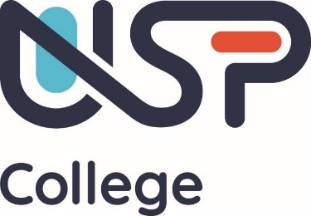

USP College Corporation

Minutes of the Meeting held on Tuesday 14 May 2024
Meeting held in the Xtend Digital Campus, Canvey Island
Meeting commenced: 17.45hrs
Meeting ended: 18.00hrs

Present
Paul Wakeling Independent Member Chair – attending remotely
Phillip Lennon Independent Member Vice Chair
Nicola Curtis Independent Member attending remotely
Vikki Liogier Independent Member attending remotely
Louise Aitken Independent Member attending remotely
Tony Wenden Independent Member
Roger Key Independent Member
Ben Akande Independent Member attending remotely
Jenny Beaumont Independent Member
Rachel May Independent Member
Dan Pearson Chief Executive Officer
Perry Sansom Staff Member
Nick Patterson Staff Member

In attendance
Steve Hendy Chief Finance Officer
Clare White Principal
Cherie Brightwell Vice Principal Technical & Professional
James Parson Vice Principal Quality & Innovation
Chris Murgatroyd Vice Principal
Mark Silverman

Clerk
Sue Glover Clerk to the Corporation attending remotely

019.24 Declarations of Interest
Members and staff were reminded of the need to declare any personal or financial interest in any item to be considered during the meeting.

There were no declarations of interest.

020.24 Apologies for absence
There were no apologies for absence.

021.24 Accountability Statement
Members were presented with the annual Accountability Statement for approval.

The Board were reminded that
- this is a requirement from the DfE for all College Boards to approve an annual Accountability Statement
- it is a 2-part document setting the overall expectations of the college in exchange for department funding investment, Part 1 is the Accountability Framework and Part 2 is the Annual Accountability Statement
- Accountability Statements form part of the wider set of reforms underway to transform the skills system, so it better supports young people and adults to develop the skills they need to get a good job and ensuring a clearer focus on the delivery of outcomes

Members reviewed the document, noting the

- College Mission and Purpose
- Communities served
- Meeting national, regional and local needs
- Approach to accountability statement
- Engagement with other providers in the area
- Contribution to national, regional, local priorities:
- College Strategic Aims and Objectives, and
- Impact and/or Contribution towards National, Regional and Local Priorities for Learning and Skills

In discussion, members considered that the document demonstrated the positive steps of bringing colleges together and providing opportunities for collaborative working. However, members raised a number of suggestions to enhance the document. It was agreed that the document would be circulated to members outside of the meeting inviting them to make suggestions to the Principal who would collage these into a final version.

It was agreed that the statement reflects the purpose, aims and objectives and should be signed by the Chair of the Corporation and Chief Executive/Principal, subject to amendments as discussed in order that the document is submitted by the deadline of 30 June.

Agreed
The Corporation Board approves the Annual Accountability Statement for 2024/25, subject to any further amendments made by members, which will be incorporated into the document by the Principal and a final version circulated to the Board prior to submission of the document by the deadline of 30 June

017.24 Any Other Business
There was no further other business.

018.24 Schedule of Meetings 2023/24
Tuesday 9 July 2024 – main Corporation Board

As there was no further business, the Chair declared the meeting closed.

SIGNED AS A CORRECT RECORD:

DATE: 9 July 2024

